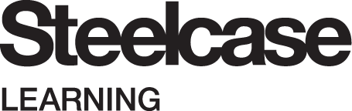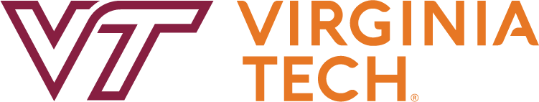

Date: October 13, 2021

FOR IMMEDIATE RELEASE
Contact:
Shannon Fitzsimons Moen, a2ru Associate Director
skfitz@umich.edu
773.420.7302

The Alliance for the Arts in Research Universities (a2ru) Announces 2022 Emerging Creatives Student Summit, “Learning in Liminal Spaces: Transformative Visions for the 21st Century”

The event returns March 9-11, 2022 in Washington DC, hosted by Steelcase Learning and CannonDesign in partnership with Virginia Tech

ANN ARBOR, Mich. and WASHINGTON, D.C.: The Alliance for the Arts in Research Universities (a2ru) is proud to announce the return of its Emerging Creatives Student Summit in 2022 after a one-year pause due to the COVID-19 pandemic. For the first time, the event will be cosponsored by two leading companies from the private sector, Steelcase Learning and CannonDesign, in partnership with a2ru founding partner institution Virginia Tech. The Summit will take place March 9-11 in Washington, D.C. at Steelcase’s WorkLife Center.

This year’s theme “Learning in Liminal Spaces: Transformative Visions for the 21st Century” reckons with a profoundly altered educational landscape as we emerge from the pandemic. Old models of learning are undergoing seismic change. We have been living with reordered routines in a time between times, learning in liminal spaces of asynchronous and hybrid instruction. Yet in this in-between time and space we now inhabit, we are freer to imagine new opportunities to access, participate, and thrive in learning. Exploring our human capacity for change in the wake of crisis, we can create more equitable and diverse learning spaces to fulfill our creative potential.

The a2ru Emerging Creatives summit will bring together students from the a2ru network in Washington DC at Steelcase’s WorkLife Center for workshops, skill building, and expert input from leaders in design, architecture, and engineering. Students will work in teams to create collaborative, transdisciplinary projects that explore how we can own these liminal, speculative, transdisciplinary spaces and transform how we learn together.

Maryrose Flanigan, a2ru Executive Director, says: “We are delighted that we can safely bring back Emerging Creatives in 2022. The opportunity to gather and learn from the extraordinarily forward-thinking, passionate students in our network is always so inspiring. This year, we are especially excited and grateful to be partnering with Steelcase Learning and CannonDesign, two companies that truly exemplify the real-world possibilities of transdisciplinary creativity and innovation. We are also tremendously thankful to Virginia Tech for facilitating this unique partnership.”

“We are thrilled to host the 2022 Emerging Creatives Student Summit in our Steelcase Worklife Center. We are really looking forward for the students from the a2ru network to explore the topic of ‘liminal spaces’ and to see what inspiring and promising learning result from the interdisciplinary teamwork,” says Andrew Kim, Steelcase, WorkSpace Futures Vertical Markets Practice Leader.

Ben Knapp, Executive Director of ICAT at Virginia Tech and Co-Chair of a2ru’s Executive Committee, adds: "We are honored to help facilitate this opportunity for students to partner with these two forward-looking companies. This summit furthers the Institute for Creativity, Arts, and Technology (ICAT) and a2ru's goal to explore new ways of collaboration between our universities and external organizations to benefit our students.”

Due to space restrictions and COVID-19 protocols and to maintain the interdisciplinary nature of the event, participation will be limited to two students from each a2ru member institution: one student from an arts-based discipline and one student from a non-arts discipline. More details on the nomination and application process will be emailed to members in November.

For more information, please visit https://a2ru.org/event/2022-emerging-creatives-student-summit

********
About Alliance for the Arts in Research Universities (a2ru)

The Alliance for the Arts in Research Universities (a2ru) is a membership network of institutions and individuals committed to ensuring the greatest possible support for arts and arts-integrative research, curricula, programs and creative practice in higher education, for the benefit of all students, faculty, and staff and the communities they serve.

About Steelcase Learning

A division of Steelcase, Steelcase Learning is passionate about helping to create the conditions for lifelong learning. Our insight-led solutions and settings inspire people to become engaged, active learners within and beyond the classroom.

Steelcase leads the way in creating great experiences by offering a range of architecture, furniture and technology products and services designed to help people reach their full potential. Together with our partners, we design spaces to help people work, learn and heal.

About CannonDesign

We leverage the heart, passion and intelligence of our more than 1,000 creative thinkers to develop solutions for the greatest challenges facing our clients and society. Whether designing for equity in education, accessible healthcare, inclusive communities, new scientiﬁc discoveries or the “next big idea” in business, we leverage our full suite of end-to-end services to help organizations and the people and communities they serve flourish.

We do this through a design approach we created called Living-Centered Design. Living-Centered Design realizes that to create a world where people continuously flourish, we must address the complex interdependencies that exist between people, businesses, communities, society and the environment. Taking this approach allows us to help organizations not only make improvements to their current state, but catalyze widespread, systemic change.

About Virginia Tech

At Virginia Tech, we're reimagining how education and technology intersect. This approach transforms the ways we teach and learn, perform research, and engage with communities around the world.

Hokies collaborate with diverse team members and cross the traditional lines between fields and disciplines to tackle global-scale problems.

We push the boundaries of knowledge in order to make a difference in the world. Members of the Hokie Nation have a clear vision of how we can serve in our personal, professional, and civic pursuits.

We are a force for positive change, driven by our motto, Ut Prosim (That I May Serve).

